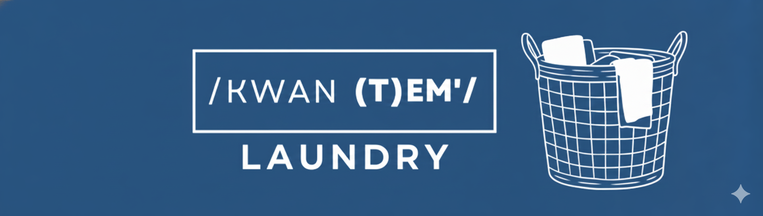

Brand Asset Usage Guidelines (Required)
By accessing and using Kwantem Cleaning Services brand assets (logos, graphics, flyers, and marketing materials), you agree to the following guidelines:Brand assets may only be used to promote Kwantem Cleaning Services and its approved services, including Laundry Pickup & Drop-Off.
Logos and materials may not be altered, recolored, stretched, or edited in a way that changes the original design.
Assets may be used on social media, flyers, digital ads, emails, and approved online platforms.
Marketers must include their assigned referral code or tracking link on all promotional materials.
Brand assets may not be used for personal businesses, misleading promotions, or unauthorized offers.
Any misuse of brand assets may result in termination of partnership and forfeiture of unpaid commissions.

